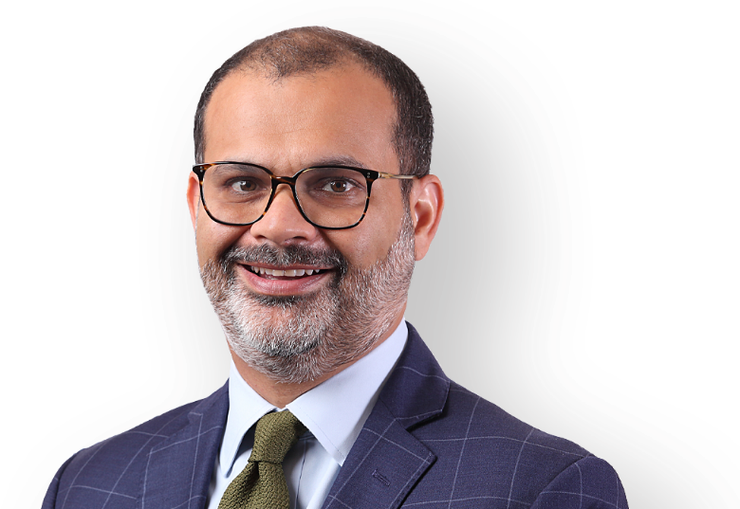
Prashant Gupta

National Practice Head
Capital Markets

Location
- Delhi

Education
- B.A. (Juris) & M.A. (Juris), University of Oxford, England
- B. Com (Hons.); Shri Ram College of Commerce, University of Delhi

Practices
- Capital Markets

Professional Membership
- Bar Council of Delhi
- State Bar of California

Awards & Recognitions
- Elite Practitioner for Capital Markets by asialaw Profiles, 2020 & 2024-25
- Leading Partner for Capital Markets by Legal 500 2020-26
- A-List of India's Top Lawyer by India Business Law Journal, 2017-26
- Recognised for Capital Markets - Debt & Equity by Lexology Index - Thought Leaders: Global Elite 2025
Prashant Gupta focuses primarily on capital markets transactions.

He represents both issuers and underwriters in various equity and debt capital raising transactions, including initial public offerings, rights issues and QIP offerings, capital restructurings, as well as offerings of dollar denominated bonds and convertible bonds. He has advised on capital markets transactions that have raised over US$ 60 billion globally, including some of the largest and most complex capital markets transactions in India while at the Firm, including:
- The four (4) largest IPOs by size, namely Hyundai Motors India, Life Insurance Corporation of India, One97 Communications (Paytm) and Coal India Limited;
- Seven (7) of the 10 largest IPOs in India by size until date;
- The first listing by an Indian company by a SPAC transaction (Videocon D2h) in 2017;
- The largest composite offering of equity shares and convertible bonds by an Indian based company (MakeMyTrip) of US$3 billon in 2025; and
- The largest bond offering by an Indian group (Vedanta) of US$1.6 billion in 2011.

Prashant has been recognised as the ‘Lawyer of the Year’ for Capital Markets by Legal 500 India Awards 2024; Global Elite: Thought Leader for Capital Markets – Debt & Equity by Lexology since 2020; Asia’s Best Lawyers by IFLR from 2019-2021 and in the prestigious ‘ET 40 under Forty’ list of 2019 by the Economic Times. He has been recognised by Who’s Who Legal (Lexology), Chambers, and Legal SS500 and other legal industry publications as one of the leading capital markets practitioners in India. He is ranked “Band 1” by Chambers Global and has been recognised as a “Market Leader” by IFLR 1000 since 2018. Since 2016, Prashant has also been selected as one of the top 100 private practice lawyers in India by, India Business Law Journal in each year.

Prashant has advised on equity and bond offerings by issuers across various industries, including Apollo Hospitals, Ather Energy, Apollo Tyres, Azure Power, AU Small Finance Bank, Bharti Airtel Limited, Brainbees Solutions Limited (Firstcry), Continuum Green Energy, Coal India, DEN Networks, Delhivery Limited, DLF Limited, Dr. Lals Pathlabs, Eris Lifesciences, Eros International, Federal Bank, HPCL–Mittal Energy, Hexaware Technologies Hyundai Motor India, IDFC, Jubilant Foodworks, KIMS Hospitals, Kfin Technologies, Lemon Tree Hotels, MakeMyTrip, Mankind Pharma, Max Healthcare, Niva Bupa Health Insurance Company Limited, One97 Communications Limited (Paytm), Interglobe Aviation (Indigo), Ola Electric Mobility Limited, ONGC, PB Fintech (Policybazaar), PVR Limited, Power Grid Corporation, PNB Housing Finance, PVR Limited, SBI Cards and Payment Services, SAMHI Hotels, Shree Cement Limited, Sula Vineyards, Network18/TV18, TCNS Clothing, Vedanta, UTI Asset Management, Vishal Mega Mart, Yes Bank and Zomato.

Awards & Recognitions
- Band 1 for Capital Markets: Equity by Chambers & Partners Asia Pacific, 2017-2026
- Band 2 for Capital Markets: Debt by Chambers & Partners Asia Pacific, 2023-26
- Lawyer of the Year for Capital Markets by Legal 500 India Awards 2024
- Market Leader for Capital Markets: Debt, Capital Markets: Equity by IFLR1000 Asia Pacific Rankings, 2023-25
- Leading Lawyer Champions for Capital Markets at the Legal Era Awards, 2023
- Band 1 in Capital Market: Equity 2023-26, and Band 2 in Capital Market: Debt by Chambers & Partners Global, 2023-26
- “ET 40 under forty” by The Economic Times, 2019
- Asia Top 15 Capital Markets Lawyers by Asian Legal Business 2022
- Global Elite Thought Leader for Capital Markets & Global Leader for Capital Markets – Debt and Equity by Who’s Who Legal, 2020-22
- Asia’s Best Lawyers by IFLR for the year 2019-2021
- Market Leader for Capital Markets by IFLR1000 - 2022
- Among the Top 100 Individual Lawyers in the Forbes, India, Legal Powerlist, 2020

He received his Bachelor of Arts degree in Jurisprudence and his Master of Arts degree in Jurisprudence from the University of Oxford, England, and his Bachelor of Commerce degree from the Shri Ram College of Commerce, University of Delhi.

Prashant in some ways is the most versatile lawyer, he can do debt and equity. Prashant is one of the rare guys who has made a reputation and is credible in both debt and equity.
– Chambers Asia Pacific Guide 2025

Prashant is a fantastic partner and one of the best in the business. He’s very thoughtful in his approach. His advice is always precise, clear and actionable.
– Chambers Asia Pacific Guide 2024

Prashant Gupta is lauded by an interviewee as “a no–nonsense lawyer who cuts straight to the point, providing crisp, balanced, commercial and technically correct advice.”
– Chambers Asia Pacific Guide 2020

Select Experience Statement
- Underwriters on Coal India Limited’s ₹ 15,475 cr IPO in 2010 – the largest IPO by an Indian company.
- Vedanta Resources plc on the US$ 1.7 billion bond offering in 2013 – the largest bond offering by an Indian group.
- Lead managers in relation to the ₹ 25,000 cr rights issue by Bharti Airtel Limited in 2019, and the US$ 3 billion simultaneous QIP & FCCB by Bharti Airtel Limited in 2020, the largest offering in India (outside a rights issue).
- Videocon d2h Limited on its US$ 273 million listing on the NASDAQ Global Market in 2015 – the first SPAC driven listing from India.
- IPOs in India by AU Small Finance Bank, Aavas Financiers, CAMS, CL Educate, DEN Networks, Dr. Lal Pathlabs, Eris Life Sciences, Hindustan Media Ventures, Indiamart, Jubilant. Foodworks, LemonTree Hotels, National Stock Exchange of India (proposed), PC Jeweller, PNB Housing Finance, Punjab & Sind Bank, SBI Cards and Payment Services, S. Chand & Company, TCNS Closing Co., UTI Asset Management, and Varroc Engineering, among others.
- QIPs by Apollo Tyres, DLF Limited, IDFC Limited, Federal Bank, HCL Infosystems, Interglobe Aviation (Indigo Airlines), Network18, PI Industries, Punjab National Bank, PVR Limited, Radico Khaitan, State Bank of India, SRF Limited, Shree Cement and Yes Bank, among others.
- IPOs in the United States by Amira Nature Foods, Azure Power, Eros International, MakeMyTrip and NW18 HSN Holdings (proposed), as well as Jubilant Energy N.V. on the London Stock Exchange.

